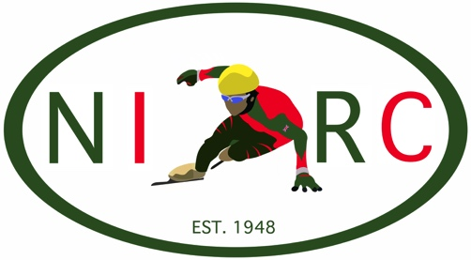
Mandy Worth
amandaworth@national-ice-centre.com
Mobile: Phone: 07810126247
National Ice Centre
Bolero Square
The Lace Market
Nottingham
NG1 1LA

NIRC One Day Camp
Working on Drills/Overtaking

National Ice Centre, Nottingham

The Nottinghamshire Ice Racing Club will once again be running a One Day training camp for skaters from all clubs.
The camp will include both on and off ice sessions.
The last camp was very popular and we look to build on that to make this one even more successful.
There will be a number of NISA coaches attending the camp and we welcome coaches from other clubs to join in as well.

We are running the camp to help improve your skating technique.

Timetable

9.00am Registration (Main Foyer)
9.30 Meeting
9.45.pm Pads on
10.00pm-11.30pm On Ice Session -Drills
12.00pm-1.00pm Lunch
1.30pm –2.30pm On Ice Session - overtaking
2.45m-3.00pm Snack
3.15pm-4.15pm Off Ice Session -Concourse
4.30pm-5.30pm Snack+ Video session
5.45pm End

Changing room to be allocated on the day of the camp.
Please bring your own food.
All times are subject to change

If you have any queries about the timetable or you are a coach wanting to help out at the camp then please contact Peter Worth —email peter.worth1@ntlworld.com, or Mandy Worth amandaworth@national-ice-centre.com

Payment Information

Payment can be made by Cash, Bank Transfer or Cheque.

*NOTE—No cash payments to be sent through the post

For bank transfers please use a Reference with your surname and the word 'Camp'

Barclays Bank

Sort Code: 20-55-68

Account Number: 90776831

Account Name: Nottinghamshire Ice Racing Club

Please make cheques payable to NIRC (Nottingham Ice Racing Club) and send with form to:
Chairman NIRC
39 Marshall Hill Drive
Mapperley
Nottingham
NG3 6FY

One Day Camp

Booking Form

29th May 2018 9.00am— 5.45pm

The camp is £40 per skater and Bookings should be sent to NIRC Chairman Peter Worth

Name
Address
________________________
Postcode
Date of Birth
Age
Telephone Mobile
Emergency Contact _______________________________________________
Email
Club Age Category Years skated

Medical Details

Chronic/on-going medical conditions
Injuries affecting training
Allergies
Current medication taken

